Aqua Knights Swim Team Family and Friends
Please come out and support this Swim Team Fundraiser!
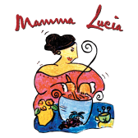
Mamma Lucia Restaurant will give 20% of sales with this flyer to support
The Aqua Knight Swim Team

Mamma Lucia is an "Authentic Provincial Italian" restaurant located at 4734 Cherry Hill Road, College Park (Marketplace – next to Shoppers)

When: Wednesday May 15, 2024
Time: 5:00 pm to 9:00 pm

You can dine-in or carry-out
20% of your bill will go to The Aqua Knights Swim Team.

