**Knights of Columbus 2809 Annual Crab Feast Sept 17th**

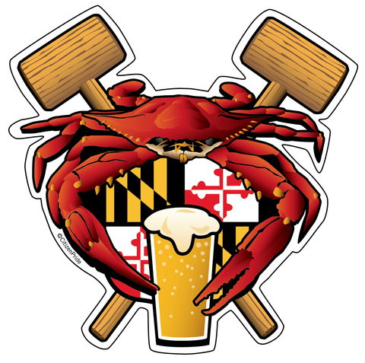

**Sunday, September 17th 2:00 – 5:00**

**All you can eat crabs, beer, soda, roast beef, green beans, hot dogs, sauerkraut, corn on the cob, home made crab soup, rolls**

**$65 pre- sale $80 at the door**

Please call Mary Fran Lintner at 301-335-3106, or email [kofcclub@aol.com](mailto:kofcclub@aol.com) for reservations. You can also buy tickets from your friendly bartender!